Worksheet 1.3: Truth tables
- Use the circuit diagram of the two-key bank vault circuit to help you complete the truth table for the AND gate. You will need to work out all the possible combinations of inputs A and B and decide on the output for each combination.

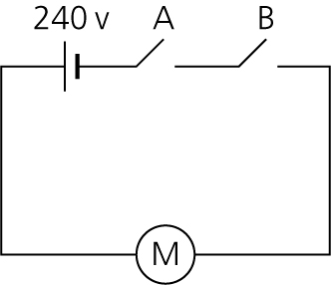

A | B | Out

- Use the circuit diagram of the automatic shop door circuit to help you complete the truth table for the OR gate. You will need to work out and all the possible combinations of inputs A and B and decide on the output for each combination.

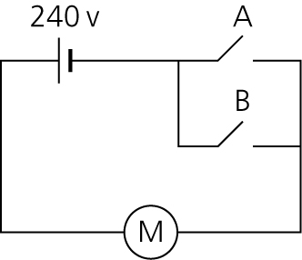

A | B | Out

